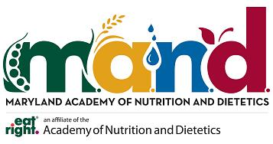

The undersigned agrees to rent the Maryland Academy of Nutrition and Dietetics list subject to the following conditions:

1, List will be used only for the one-time direct mail purpose for which it was approved.
a. Program Title: _______________________________________________
b. Location: ___________________________________________________
c. Date: ______________________________________________________

2. List will not be duplicated, resold or integrated into a permanent database.

3. Payment must be received before the mailing list will be released.
Having read the above, the undersigned agrees to assume full responsibility for breach
of these terms. Noncompliance will disqualify the undersigned from receiving future list
rentals from the Maryland Academy of Nutrition and Dietetics.

Bill To:

Ship To:

Authorized Signature: ________________________________________________________
Print Name and Date: ________________________________________________________
Title and Phone Number: _____________________________________________________

Please select:
_______ Complete membership list ($150.00 for-profit/$100.00 non-profit)
_______ Partial membership list ($20.00 admin fee + 0.15 per member requested)

Discuss availability with Maryland Academy Executive Director.

E-mail Excel database to: execdirector@eatwellmd.org
______________________________________________________
Please return rental agreement and payment to:
Maryland Academy of Nutrition and Dietetics
P.O. Box 571
Sparks, MD 21152

Questions? Phone 410.929.0764 or e-mail: execdirector@eatwellmd.org

