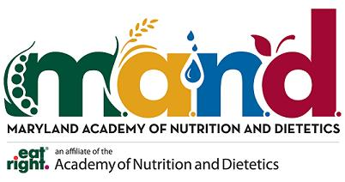
Maryland Academy of Nutrition and Dietetics
Speaker’s Bureau Application Form

Please fill out completely and e-mail to Dr. Meena Somanchi at drsomanchimda@gmail.com.

Name of Organization:
Address:
Parking facilities:
Title of Topic(s):
Number of sessions:
Duration of session (hours):
Dates and time of sessions:
A brief paragraph of your company:

Type of audience (children, adults, seniors, special group with a particular disease, etc) :
Compensation/honorarium provided:
Any other details:

